**COIS 2240 – Assignment 2 Marking Scheme**

Question 1: _/5

Question 2: _/5

Text highlighted in yellow are grade allocation

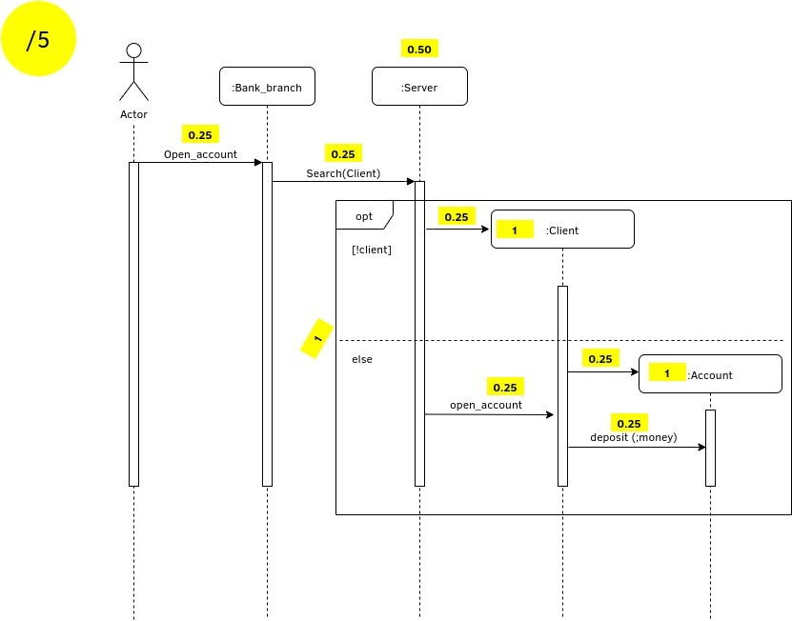

Question 3: _/5

Text highlighted in yellow are grade allocation

